**Huawei challenge**

Vision is to connect devs with consumers: Challenge to create an app on the mobile phone

Develop an innovation Android app using HMS Core SDK tool kit

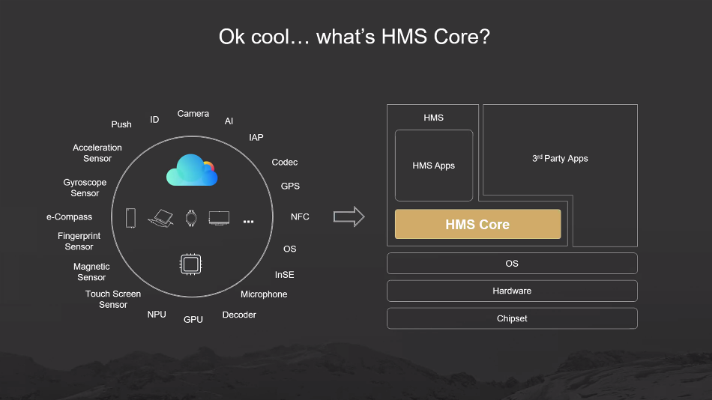

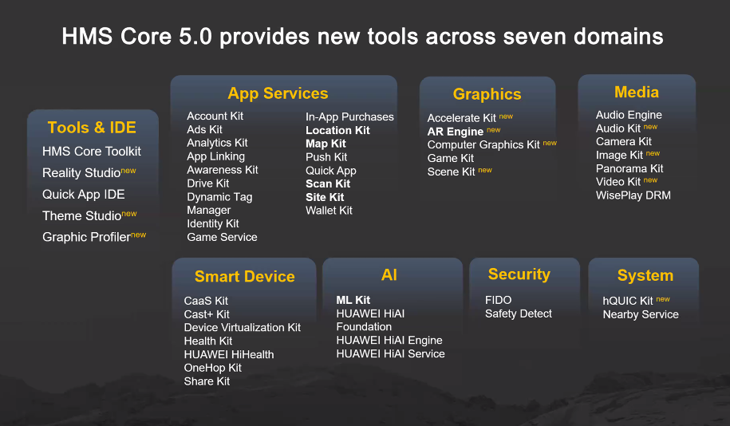

ML K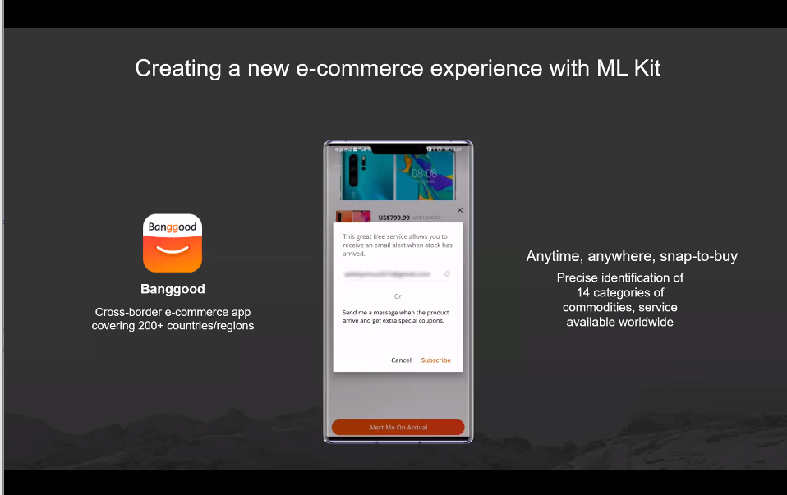

ML KIT, runs on all Android devices

AR Engine, Richard

**Logitech**

Digital Creatvies, MX Master 3,

Define Future of Creation

Coding to Animating > heavy tools, heavy workflows, emapthize

New forms improve efficiany with better workflows, specific industry and create system or tool

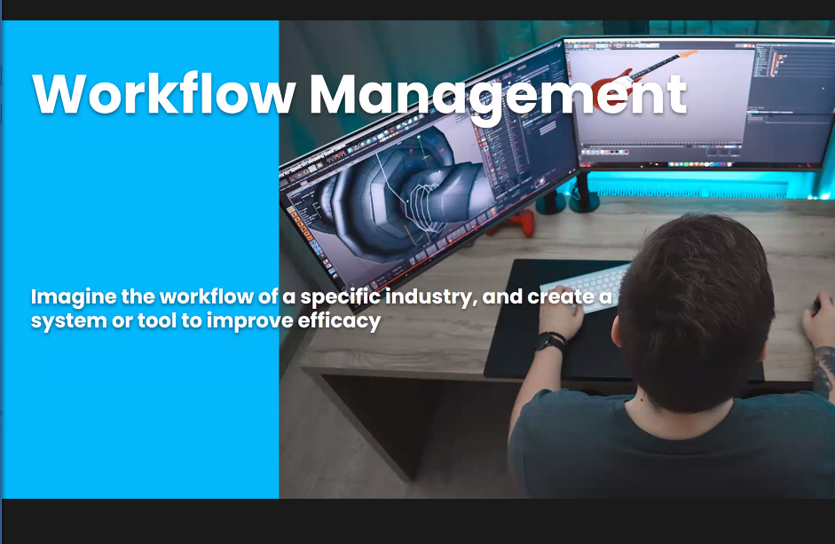

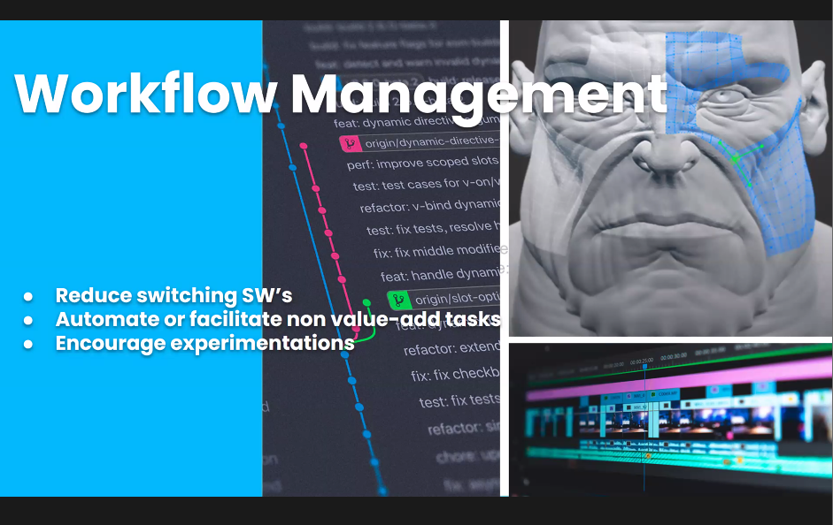

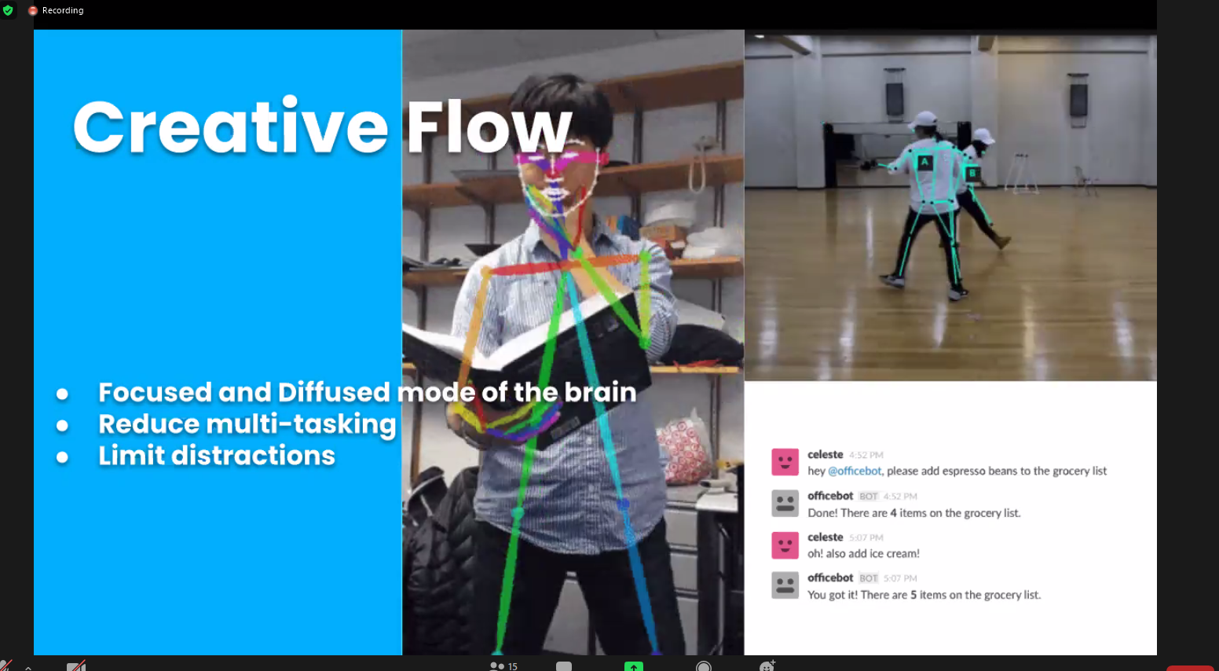need:

Let people focus on their process and not distract them while helping them beneficently